**Liebherr Service App Documentation**

Project summary:

* The navigation through the whole application is performed using b-nav elements (Vue bootstrap); consequently additional navigation elements can be freely added accordingly.
* Language switcher (vue-i18n) is applied through the application. The user can choose English or German language based on his perference.
* The application is device friendly (responsive). It was tested and verified on different types of devices using online tools.

The application has two main areas, which you can navigate to, on the home page:

* Unregistered Area:

The area includes two components:

**Products:** It encapsulates two vue-carousel-3d elements. Routing is implemented for each slide

in the two carousels, including one example information page:-

* Liebherr components carousel

(An example information page is implemented for the Diesel motor component using b-table)

* Commercial spare parts carousel.

**Contact:** A static image of contact information.

* Registered Area:

A secure authentication process was implemented. Bcryptjs (hash and salt methodology) was

utilized to encrypt the user given password.

Mongodb was used to store the relevant user data (user name, password, email, and id).

The area comprises two components; signup and login.

**Sign up:** The user should fill up the required information (read through b-form-input elements) to register. After successfully signing up, the user is automatically navigated to the login component.

**Login:** Registered users can login by typing in their user name and password (b-form-input). After successfully logging in, the user is automatically navigated to the account component, which is presented below.

* **Account:** The page contains two routes; failure plan and chat function.
* **Failure Plan:** An example plan was implemented (Fehlersuchplan P1019). The working flow of which is as follows:

1. Input the id “P1019-00” in the Id field.

2. The first step, that the technician should do, will be shown automatically in the

Input and Output fields.

3. The technician adds the result of the step, he performed (“ i.o.”, “ n.i.o.” or

“<empty string>”) in the input field.

4. The next step will be shown on the output field automatically.

5. Continue likewise until you get the message “submit results”.

6. After submitting, a report page will be displayed (routing only done; not

implemented)

* **Chat:** An open area for chatting was implemented, in which logged in technicians can call for support on necessary matters. (Socket i.o was utilized to implement the chatting funciton.)

**Implemented requirements:**

1) The app is usable with a smartphone (“Responsive Design”).

2) The app has an open and a closed area for registered users.

3) The app is multi-lingual (english/german).

4) The app implements the Corporate Identity (CI) of Liebherr.

5) The app shows an implementation example of the “Fehlersuchplan”.

6) The app includes a support area (chat function for registered users) in addition to an inviting display for products using 3d Carousels.

**Installation Manual:**

**Visual Studio code, NodeJS, npm, vuejs**

**VSCode and Vuejs must be installed then the project should be imported.**

See VSCode Vue Tutorial :

<https://code.visualstudio.com/docs/nodejs/vuejs-tutorial>

**Prerequisite: NodeJS and npm must be installed on the computer.**

* npm install -g @vue/cli
* vue create <project name>
* cd <project name>
* npm run serve
* npm install vue-router

**Client-Framework Vue.js:**

* Vue.js was used as a client framework for frontend.
* Vue-bootstrap, css, javascript were used during the course of development.
* Routing: (Router.js, Guard.js)
* Internationalization: (I18n.js, Translation.js, constants (trans.js), locales (de.json, en.json))
* CSS: custom.scss, mycss.css
* Vue Components: Components folder

**Multi-Language Support:**

For Multilanguage support we have used Vue-I18n plugin and vue-i18n – starter

Github https://github.com/dobromir-hristov/vue-i18n-starter

**Usages:**

**(In project root dir) npm install vue-i18n**

“Default language, supported languages and fallback language can be setup inside

Constants/trans.js.”

export const DEFAULT_LANGUAGE = 'de'

export const FALLBACK_LANGUAGE = 'en'

export const SUPPORTED_LANGUAGES = ['de', 'en']

**Server-Side Programming / NodeJs:**

NodeJs, API Functions, Express Routing, MongoDB and Express were used.

**Express app skeleton:**

Install (globally for all users):

$ npm install express-generator –g

**Websocket:**

Websocket was used for real time interaction in chat.

Socket.Io allowes us to emit and receive custom events.

Install Socket.io module

npm install –save socket.io

[https://socket.io/docs/#Using-with-Express](https://socket.io/docs/%23Using-with-Express)

**To install all of the dependencies**

**All of the dependencies must be installed to run the project successfully.**

**Setting up** axios: npm init –y npm i axios

**Setting up** babel: npm install babel-cli babel-core --save-dev

**Setting up** bcryptjs: npm install bcryptjs

**Setting up** body-parser: npm install body-parser

**Setting up** bootstrap: npm install bootstrap@3

**Setting up** bootstrap-vue: npm i bootstrap-vue

**Setting up** cache-loader: npm i cache-loader

**Setting up** concurrently: npm i concurrently

**Setting up** connect-flash: npm i flash

**Setting up** copy-webpack-plugin: npm i copy-webpack-plugin

**Setting up** core-js: npm i core-js

**Setting up** cors: npm i cors

**Setting up** css-loader: npm i css-loader

**Setting up** dotenv: npm i dotenv

**Setting up** ejs: npm i ejs

**Setting up** express: npm install express

**Setting up** express-ejs-layouts: npm i express-ejs-layouts

**Setting up** express-session: npm i express-session

**Setting up** i18n: npm i 18next

**Setting up** jquery: npm i jquery

**Setting up** jsonwebtoken: npm i jsonwebtoken

**Setting up** mongoose: npm i mongoose

**Setting up** node-sass: npm i node-sass

**Setting up** npm: npm i npm

**Setting up** passport: npm i passport

**Setting up** passport-jwt: npm i passport-jwt

**Setting up** passport-local: npm i passport-local

**Setting up** sass-loader: npm i sass-loader

**Setting up** socket.io: npm i passport-jwt

**Setting up** uws: npm i uws

**Setting up** vue: npm install vue

**Setting up** vue-carousel-3d: npm i vue-carousel-3d

**Setting up** vue-router: npm i vue-router

**Setting up** vue-socket.io: npm i socket io

**Setting up** vuex: npm i vuex

**Setting up** @vue/cli-plugin-eslint: npm i @vue/cli-plugin-eslint

**Setting up** @vue/cli-service: npm i @vue/cli-service

**Setting up** babel-eslint: npm i @babel-eslint

**Setting up** eslint: npm i eslint

**Setting up** eslint-plugin-vue: npm i eslint-plugin-vue

**Setting up** nodemon: npm install nodemon

**Setting up** vue-template-compiler: npm install vue-template-compiler

**User manual**

To successfully run the project, mongoDB must be installed on your pc. Then create a new database or you can use mongoDB test database. Afterwards you have to fix the database path and name on the keys.js file in the project directory. After that you have to open the project folder (liebherr1-master) using visual studio code. Here liebherr1-master is the project name. Finally, to run the project you have to write the following commands in the project terminal

* npm run serve
* node app.js
* chat.js

After running those commands, a localhost link will appear, on which you can click and the project will be opened in a new browser tab. If any dependencies are missing, the terminal will provide a message stating which dependencies should be installed. All of our dependencies list including the associated installation commands are shown above.

**Technical remarks:**

Connection between server side and client side:

* In the main.js a file a vue Instance is created that uses the store from store.js.
* Store.js is using vuex (getters, actions, mutations) to import functions which are implemented in warehouse/Auth.js.
* Auth.js is using axios to manage http requests.
* Http requests are then dealt with using express router.
* Users.js is using the express router.
* In app.js a new express instance is instantiated which uses routes form Users.js.

Authentication process:

* JWT assigns a token for each user login.
* getProfile() in Auth.js is using the jwt-strategy developed in Passport.js as follows:

JWT -> (Assigns) Token -> (Checked by) Passport -> (Access) Profile

**Screen shots of our project:**

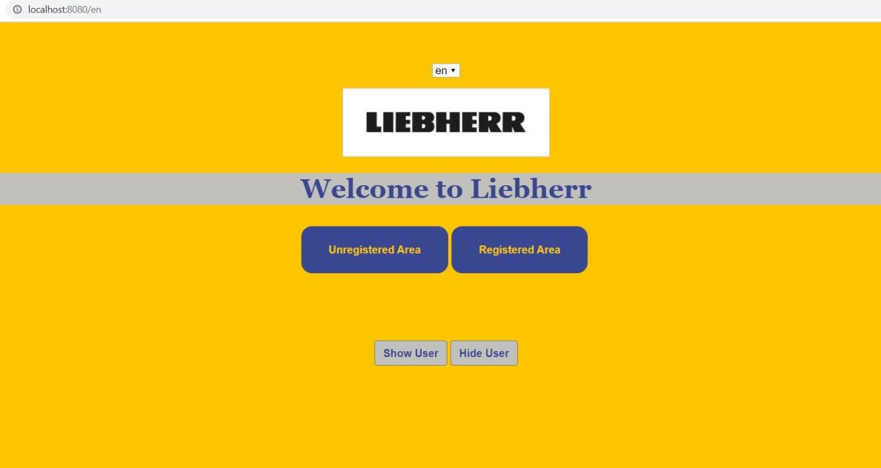

**Home**

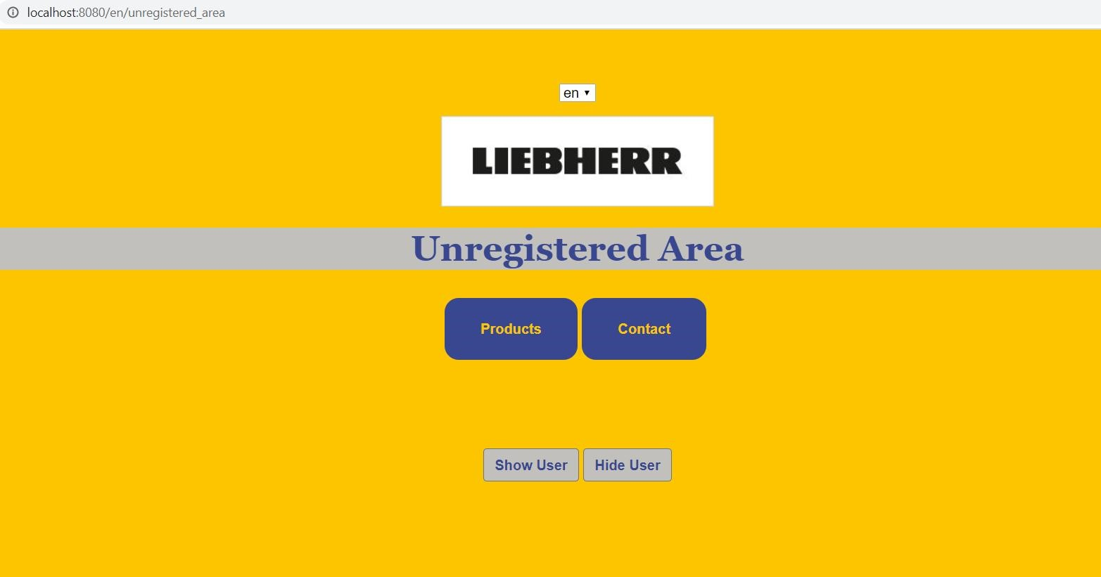

**Unregistered Area**

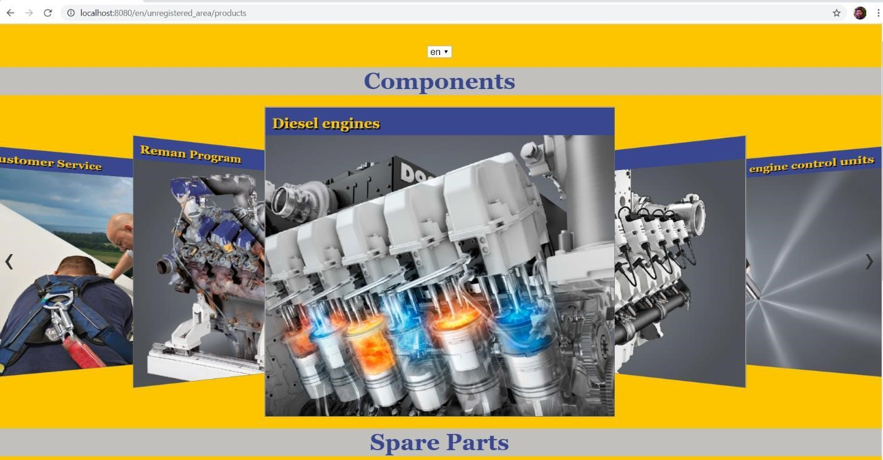

**Products**



**Products**

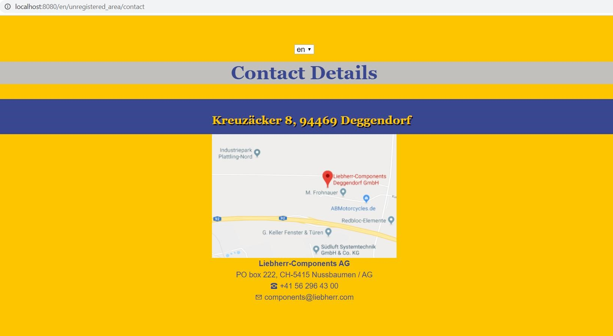

**Contact**

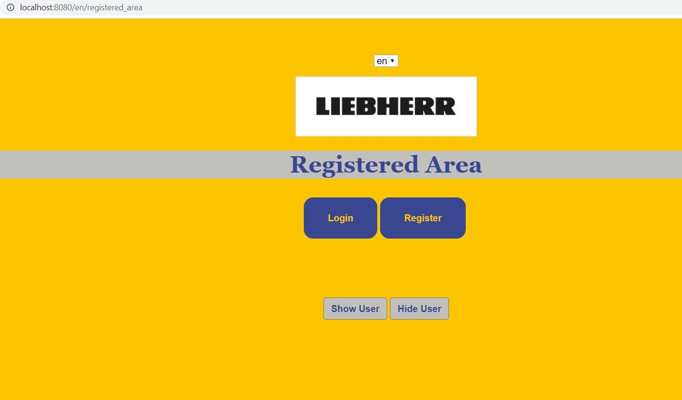

**Registered area**

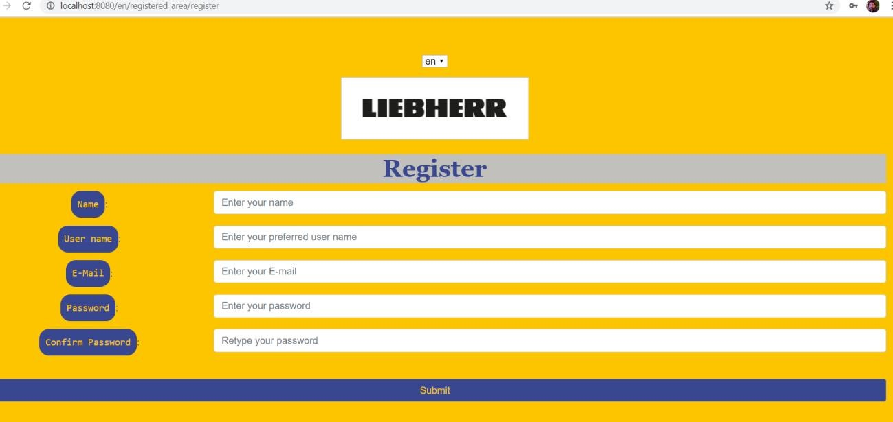

**Register**

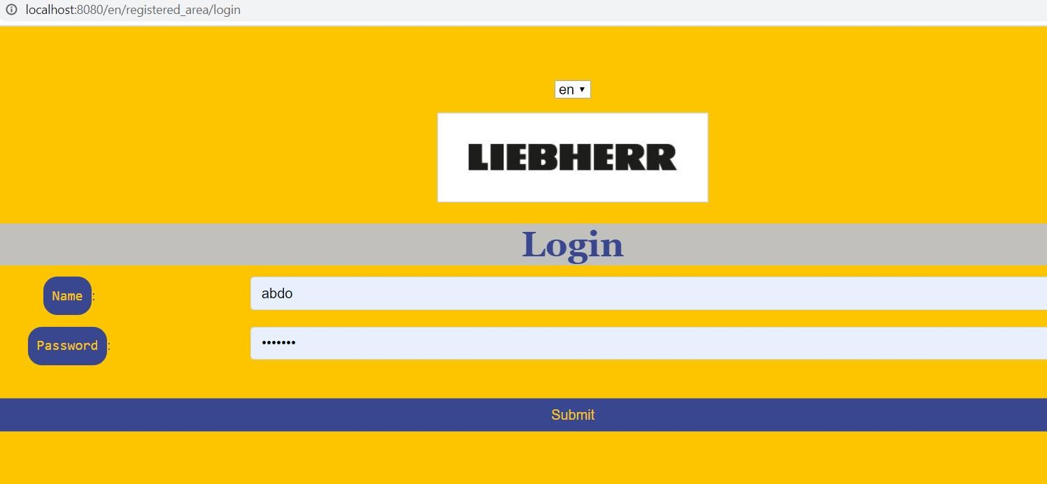

**Login**

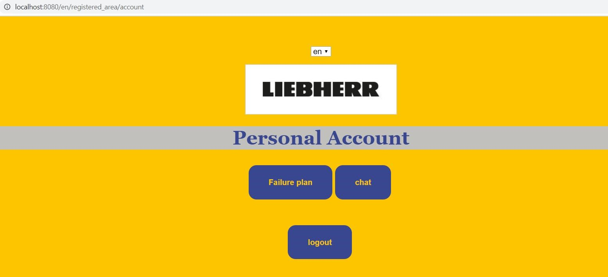

**Account**

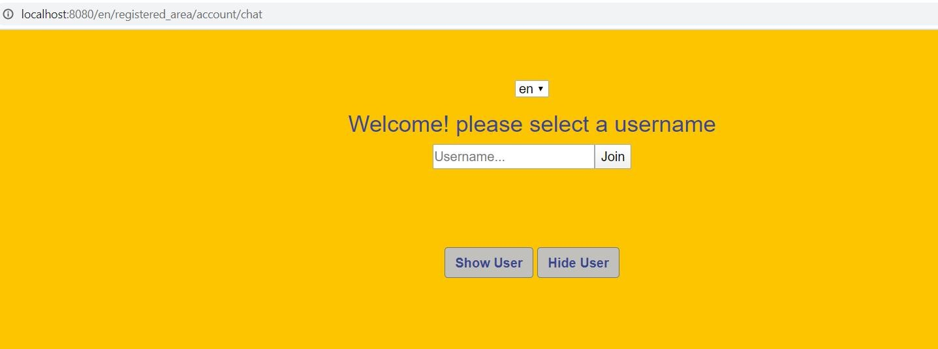

**Chat**

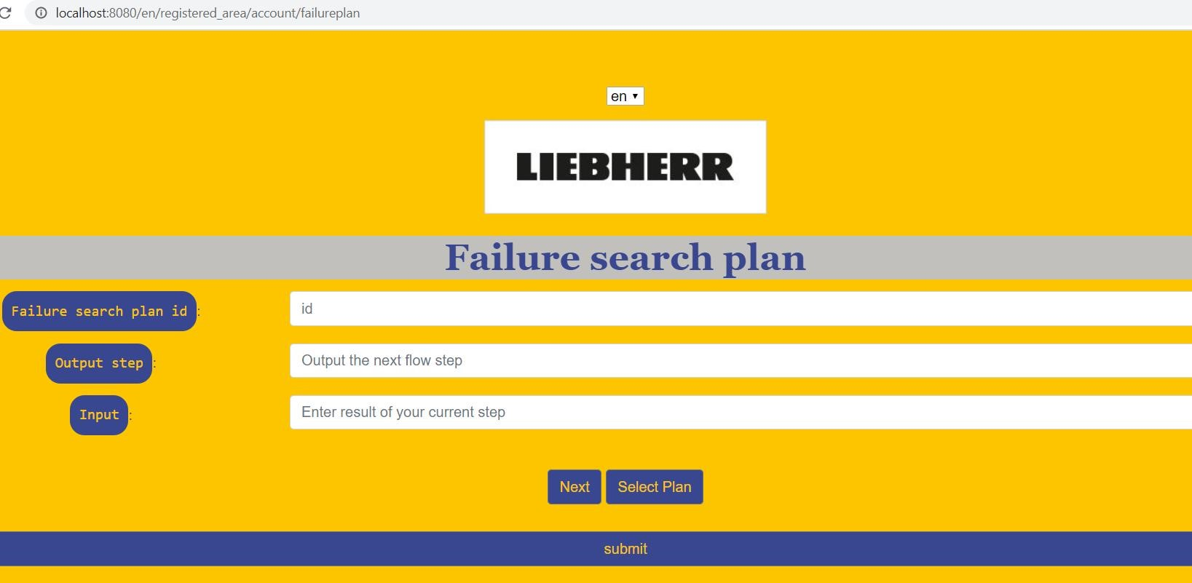

**Failure plan**

A short video about the application also uploaded in the git repository